
Name & Department
Mark Forster
Sales Department (New York)
mark.forster@apple.com
Date: 5th September 20XX

One-on-One Template Form:
Manager Feedback

OPEN AN INTERACTIVE TEMPLATE?
Use this link to open this template in the Echometer 1:1 Meeting Tool - and get an automated history to identify development trends.
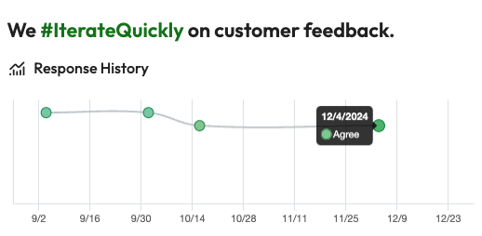

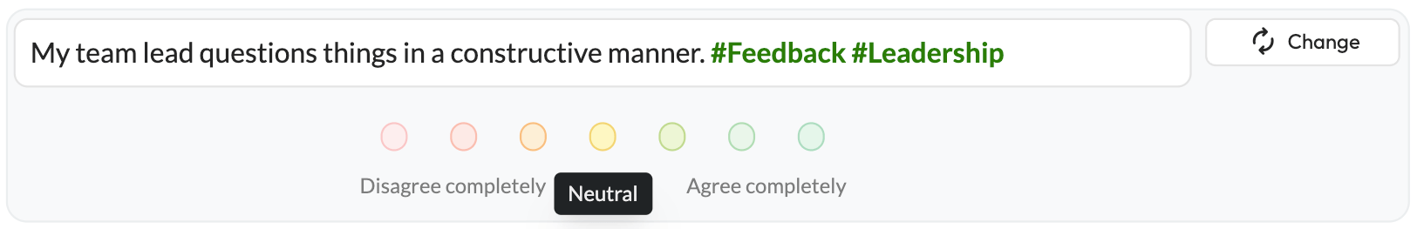
SURVEY QUESTIONS: PERSONAL DEVELOPMENT

- How much do you agree with the statement above and why?

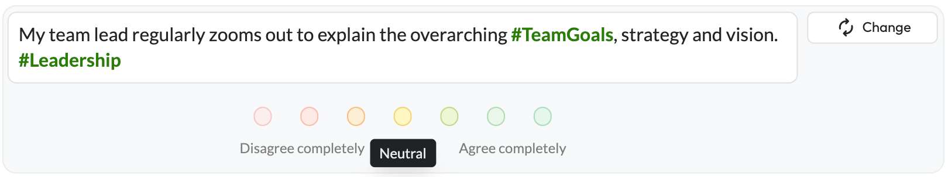

- How much do you agree with the statement above and why?

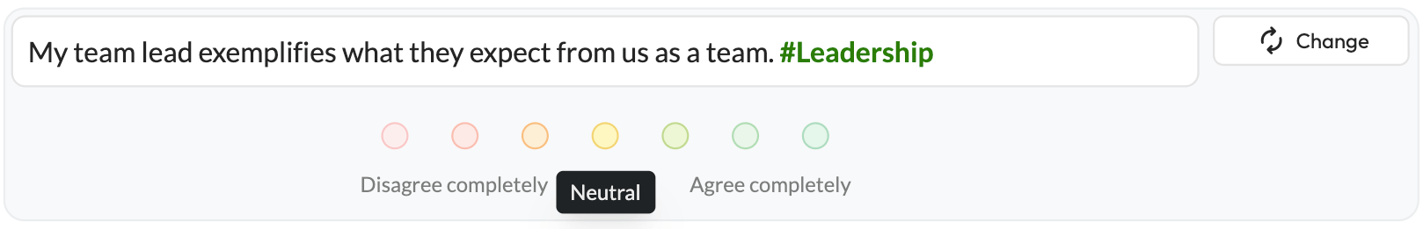

- How much do you agree with the statement above and why?

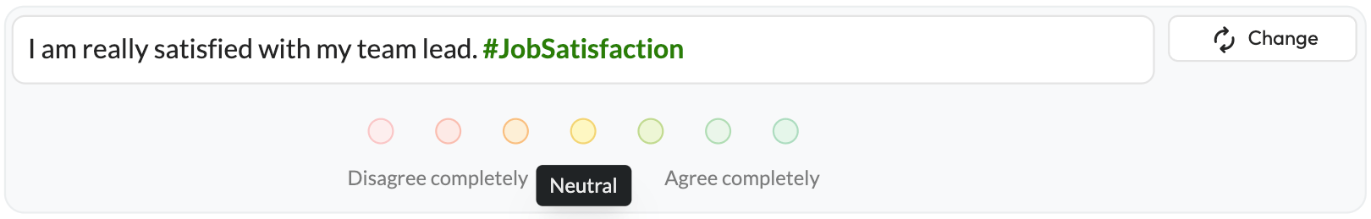

- How much do you agree with the statement above and why?

CLOSING
- How did you like today’s One-on-One including the format?
- How often would you like to review these topics?
- Do you have any further questions or concerns?

